Sequence Diagram

[Sequence diagrams](https://www.smartdraw.com/sequence-diagram/) describe interactions among classes in terms of an exchange of messages over time. They're also called event diagrams. A sequence diagram is a good way to visualize and validate various runtime scenarios. These can help to predict how a system will behave and to discover responsibilities a class may need to have in the process of modeling a new system.

How to Use [Sequence Diagrams](https://www.smartdraw.com/sequence-diagram/)

* Model and document how your system will behave in various scenarios
* Validate the logic of complex operations and functions

Basic Sequence Diagram Symbols and Notations

**Class Roles or Participants**  
Class roles describe the way an object will behave in context. Use the UML object symbol to illustrate class roles, but don't list object attributes.

Object symbol - Sequence diagram

**Activation or Execution Occurrence**  
Activation boxes represent the time an object needs to complete a task. When an object is busy executing a process or waiting for a reply message, use a thin gray rectangle placed vertically on its lifeline.

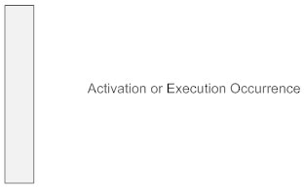

**Messages**  
Messages are arrows that represent communication between objects. Use half-arrowed lines to represent asynchronous messages. Asynchronous messages are sent from an object that will not wait for a response from the receiver before continuing its tasks. For message types, see below.

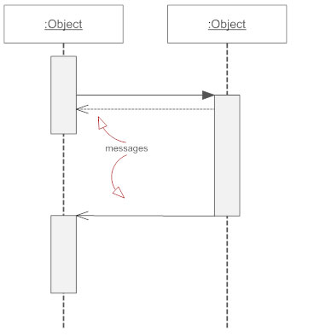

**Lifelines**  
Lifelines are vertical dashed lines that indicate the object's presence over time.

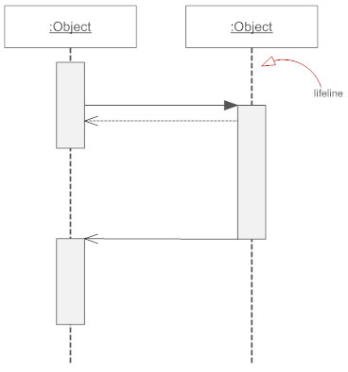

**Destroying Objects**  
Objects can be terminated early using an arrow labeled "<< destroy >>" that points to an X. This object is removed from memory. When that object's lifeline ends, you can place an X at the end of its lifeline to denote a destruction occurrence.

**Loops**  
A repetition or loop within a sequence diagram is depicted as a rectangle. Place the condition for exiting the loop at the bottom left corner in square brackets [ ].

Types of Messages in [Sequence Diagrams](https://www.smartdraw.com/sequence-diagram/)

**Synchronous Message**  
A synchronous message requires a response before the interaction can continue. It's usually drawn using a line with a solid arrowhead pointing from one object to another.

Synchronous message - Sequence diagram

**Asynchronous Message**  
Asynchronous messages don't need a reply for interaction to continue. Like synchronous messages, they are drawn with an arrow connecting two lifelines; however, the arrowhead is usually open and there's no return message depicted.

Simple messageAsyncrhonous message

**Reply or Return Message**  
A reply message is drawn with a dotted line and an open arrowhead pointing back to the original lifeline.

Reply messages

**Self Message**  
A message an object sends to itself, usually shown as a U shaped arrow pointing back to itself.

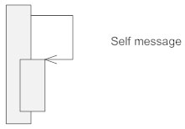

**Create Message**  
This is a message that creates a new object. Similar to a return message, it's depicted with a dashed line and an open arrowhead that points to the rectangle representing the object created.

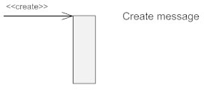

**Delete Message**  
This is a message that destroys an object. It can be shown by an arrow with an x at the end.

Delete message

**Found Message**  
A message sent from an unknown recipient, shown by an arrow from an endpoint to a lifeline.

Found message

**Lost Message**  
A message sent to an unknown recipient. It's shown by an arrow going from a lifeline to an endpoint, a filled circle or an x.

Lost message